**INSTRUCTIONS TO RUN PROJECT**

Step 1

Download Xampp

Step 2

Download code and extract code

Step 3

Go to htdocs folder in xampp

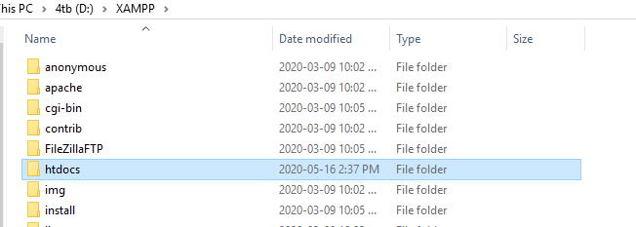

Step 4

Open Xampp control



Step 5

Start Apache and MySQL

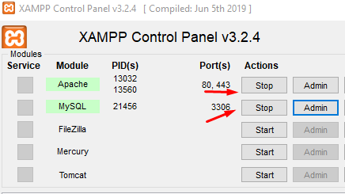

Step 6

Go onto chrome and type in localhost it should redirect you to localhost/login/index

